My Time:
Parent’s Day Out
Handbook

2020 – 2021

Dear Parents,

I would like to welcome you and your child to our program. It is my sincere desire that your association with our school be a happy and rewarding experience.

This booklet has been prepared to help acquaint you in advance about our policies, and to promote a mutually beneficial understanding between our school and your family. Please take the time to read it thoroughly. I sincerely hope that by working together we can give your child a solid foundation on which to build in future years.

Our staff appreciates you sharing this part of your child’s life with us. Your children are a blessing to us because we are able to contribute to their early education.

If you have any questions or concerns about our school policies or procedures, please contact me in the preschool office.

Blessings,

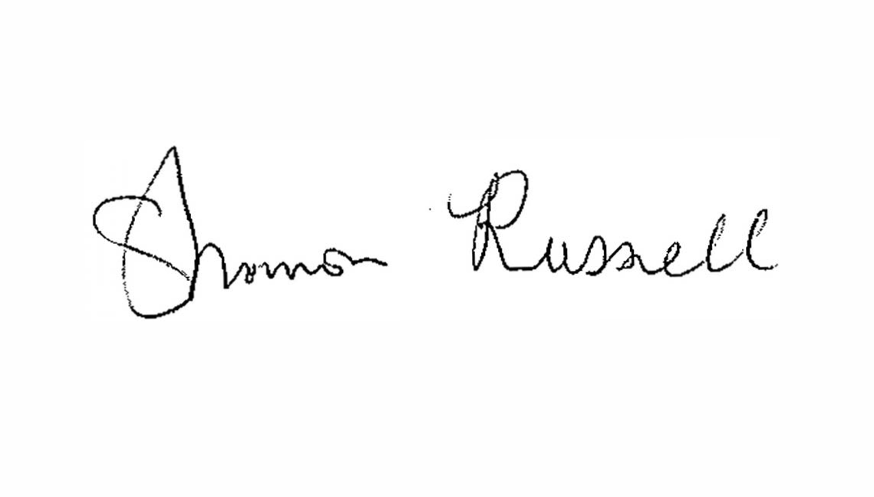
Shannon Russell
My Time Director
Peace Lutheran Church
941 Bedford-Euless Road
Hurst, Texas 76153
Phone: (817) 284-1677 ext. 213
Email: Shannon@PeaceChurch.org
Website: www.PeaceChurch.org

Table of Contents
General Information 4
Educational Philosophy 4
Christian Mission Statement 4
Purpose 4
Staff 4
report abuse & neglect of children 5
Enrollment Requirements 5
Available Classes 5
Tuition & Fees 5
Curriculum 6
Special Days 6
Starting School 6
How Parents Can Help 7
Daily Checklist 7
Attendance Policies and Procedures 7
Arrival/departure procedures 7
Before/After School Conduct 8
Security Policy 8
Communication 8
Volunteers 8
Discipline 9
Visiting 9
Inclement Weather 9
Clothing 9
Snack/Lunch 10
Toys from Home 10
Toilet Training/Accidents 10
Illness and Medication 10

General Information
Office Hours:
Monday 9:00am – 12:00pm
Tuesday Closed
Wednesday/Thursday 8:30am – 3:00pm
Friday Closed

Educational Philosophy
My Time believes our Christian-based early childhood program provides a secure environment which promotes spiritual, cognitive, social, physical and emotional development of children and their families.

We encourage the growth of a loving relationship with Jesus Christ by modeling, teaching and practicing age-appropriate components of spiritual development. Our curriculum and policies are inclusive, unbiased and reflect the diversity of children and their families in our community and the world around us.

We require our staff to participate in continued learning opportunities which include development in faith; understanding of how children learn, grow and develop; and knowledge of resources which help support families.

Christian Mission Statement
My Time is a weekly Christian Parent’s Day Out ministry of Peace Lutheran Church that serves and equips students and their families to grow socially, spiritually, and educationally as unique children of God in a secure, nurturing and professional environment.

Purpose
Our purpose is to provide a secure environment that promotes spiritual, cognitive, social, physical, and emotional development of children and their families.

Staff
The teachers work as a team. They work together to serve and equip students and their families to grow socially, spiritually and educationally as unique children of God in a secure, nurturing environment through age-appropriate activities. The staff attends an orientation outlining My Time’s guidelines, expectation, and program goals. In addition, they attend training classes and receive on-going support throughout the year.

All staff members are certified in CPR and first aid training
and are screened prior to hiring and/or working with children.

Report Abuse or Neglect of Children

To report child abuse or neglect, call 1-800-252-5400 or use their secure website: https://www.txabusehotline.org. You may also contact the Local Texas Department of Public and Regulatory Services in Hurst at 817-427-1865

Enrollment Requirements
Complete the registration form and pay the $30.00 enrollment fee. The registration form includes: student information, parent information, emergency medical authorization, allergy information, media waiver and medical – liability release.

Available Classes
All classes are always contingent upon reaching a minimum number of enrollees.

18 Months – 24 Months (Children must be 18 months by September 1)
One or Two Days a Week
Wednesday and/or Thursday 9:00am – 12:30pm or 9:00am – 2:30pm

25 months - 3 Years Old (Children must be 25months by September 1)
One or Two Days a Week

Wednesday and/or Thursday 9:00am - 12:30pm or 9:00am - 2:30pm

Tuition & Fees
Tuition is due by the first Wednesday of the month September – May. Tuition is calculated on a 9-month school year. Please make checks payable to: Peace Lutheran Church. You may pay online using the link on the Peace Church website or by check. Your check will serve as your receipt unless you request otherwise.

There is a 10% discount for families with multiple children. This discount applies to the tuition portion only for the 2nd child. Late fees of $5.00 per school day will be applied, after a 1-week grace period.

There is also a $25.00 charge for a returned check to the preschool.

Curriculum
The curriculum for all groups is designed to be developmentally appropriate to build upon skills learned at the previous level. Children are first encouraged to explore God’s world with all their senses through teacher-directed activities. Children are inspired to learn through play and exploration at classroom centers.

Bible Story time is another part of the curriculum. These lessons include Bible stories and Christian values integrated with traditional preschool themes, such as health and safety, self-awareness, community helpers, seasons, and holidays. These resources provide an expanded preschool learning opportunity to grow socially, intellectually, and spiritually.

Our daily routine incorporates all of the functional child development areas of social, physical, and emotional development through art, music, fine motor skills, large body movement, and nutrition. Stories, learning centers, and rest times are also part of our daily routine.

Special Days
Chapel - All children attending My Time/PDO will attend chapel each Thursday with the students and staff of Red Apple. This service consists of songs, prayer, and a short lesson. Chapel begins at 9:30am in the Worship Center. Parents are invited and encouraged to attend Chapel any time. A chapel offering is collected each week for our local food bank, North East Emergency Distribution (N.E.E.D). You may send a non-perishable food item or paper product with your child to help meet the needs of the families they serve.

Birthdays – Children may bring a special snack for their class on their birthday. Please let the teacher know in advance when you plan to serve refreshments.

Holidays – School parties will be held celebrating Rodeo Day, Christmas, and Valentine’s Day. Parents will be asked to sign up to coordinate and help with one or more of these parties.

Starting School
Children are usually excited about starting school; however, they may be a little apprehensive as the day approaches. Here are a few things a parent can do to help the situation:

Treat the school as a normal part of life, something that is casually accepted.
- Be positive, excited, happy and reassuring to your child about starting school
- Create a normal routine at home for them
- Listen and answer any questions your child may ask about school
- Make sure your child gets enough sleep the night before a school day; 10 to 12 hours is the average amount of sleep for a preschool age child.

Entrust your child with his/her teacher as they know and understand the needs of children. Our teachers are here to love and nurture them in the way they should grow. Please love on your child, reassure them you will be back to pick them up, then we ask you leave promptly.

How Parents Can Help
Your involvement in our My Time/PDO program is vital to our success. Please contact your child’s teacher to find out ways you can be of assistance. Your child’s teacher will have many opportunities for you to help out at the school and in your child’s classroom.

Take a few minutes each day to look at your child’s work. It represents your child’s effort in preschool, and your praise will encourage all future efforts. Ask your child about the work they bring home. Compliment them on their effort, use of color and/or design. Try not to “label” it with a name as often we are mistaken about what they have created.

Feel free to visit your child’s classroom any time after your child has made the adjustment to school. Speak to your child’s teacher about a good time for you to observe.

Always feel free to call and check on your child while he/she is at the preschool. Your peace of mind is worth the call.

Daily Checklist
As a reminder, each day when you bring your child to My Time/PDO, be sure to bring the following:

- Extra clothing, including socks and underwear (This can be left in your child’s cubby and be changed as the weather changes.)
- Properly packed diaper bag for toddlers, or tote bag/backpack for older children to carry their belongings. We require the use of disposable diapers.
- Lunch (peanut free) with a drink.
- Make sure your child is wearing sneakers for their safety at school.

Attendance Policies and Procedures
Please call (817) 284-1677 ext. 213 or email shannon@peacechurch.org if your child will be absent because of illness, vacations, or any other reason. If you know in advance, please notify the teacher, as it is helpful for planning. Prompt arrival of your child is very important for your child, teacher, and fellow classmates. This helps create good structural habits.

Arrival/Departure Procedures
My Time/PDO doors open at 8:55 am. We ask you to please give teachers time to properly prepare for the start of your child’s day. An adult must accompany all children to their classroom(s). There will be a sign-in sheet in each classroom for the parents to complete each day. Please remember to provide a phone number on the attendance form where you can be reached in case of an emergency.

Pick up time for half day students is 12:30pm, full day students is 2:30pm.
If you are unavoidably detained or if there is a change in who is to pick up your child, please call or email as soon as possible.

We encourage parents to be prompt when picking up their child. Children become concerned if they wait longer than the others. A $10.00 late fee will occur after the first 15 minutes and a $1.00 fee for every minute thereafter that the parent is late.

Before/After School Conduct
Please teach your child to be respectful of the school rules by helping them follow our rules before and after school. Remind your child to walk, not run in the hallways or Sanctuary, as running is not allowed. If you would like to visit with other parents before/after school, please do so while supervising your children on the playground. We ask you to have your child follow the playground rules. These rules are for everyone’s safety

Security Policy
Parents or guardians are responsible for the transportation to and from school. Only those people listed on your child’s enrollment form will be allowed to pick up your child from school. If in an emergency, your child needs to be picked up by anyone other than the persons stated on your form, please (1) NOTIFY THE DIRECTOR (2) advise the person to check in with the director upon arrival and present their driver’s license before the child will be released to them. The director and teachers will not release your child to someone who is not listed on the sign-in sheet or as a contact person

My Time/PDO operates on an open door policy and parents of children enrolled in the program are welcome to visit and observe their child’s class at any time. This is to provide parents with the added security of knowing they are welcome at our school.

Communication
A newsletter about My Time/PDO, Red Apple School, and Peace Lutheran Church activities will be published on a monthly basis. Teacher notes help keep the channels of communication open between the parents and the school. Parents are welcome to contact the teachers or the director at any time.

Volunteers
There will be opportunities to help in your child’s class throughout the school year. If it is disruptive to your child to see you in the classroom, you may need to discuss with the teacher what is best for your child. There are many opportunities to help out the whole school not just each classroom.

Discipline
We want to provide a positive and nurturing environment for your child. We always try to work with any child and parent when a problem arises, but we also must consider what is best for the classroom as a whole. Discipline and guidance of children will be consistent and based on an understanding of individual needs and development, and shall be directed toward teaching the children acceptable behavior. Children will be disciplined in a positive manner which encourages self-control, self-esteem, and self-direction.

It is important for you to notify the teacher/director if your child is experiencing a change in the home environment that may result in changes in behavior at preschool. The teacher/director will also immediately notify a parent in the event of a behavioral problem that consistently exists. The staff will work with parents and do their best to serve the needs of each child as an individual.

Visiting
You are always welcome to visit with your child’s teacher and the other parents of children in the class. Once the class has begun, please move outside or to an area in the building away from the classroom. This will ensure that classes are not disturbed. Please do not request a “doorstep” conference with your child’s teacher. The teacher has a full schedule of activities planned for her students and it is important that class begins on time. If you have a concern about your child, you may leave a message for the teacher or give her a note and she will get back with you. Any problems will be handled in a timely manner.

Inclement Weather
While in session, My Time/PDO follows the HEB ISD calendar. When the HEB schools are closed due to bad weather, our school will also be closed. If HEB ISD has a delay, we will be closed for the day. To hear school closings, please tune in to your local radio or TV station to check for school closings or delays. If it appears that the weather is becoming hazardous (example: icy streets, heavy sleet, tornado warnings, or snow), please pick up your child immediately. Do not wait for a call from the preschool.

Clothing
Your child will be spending a large part of the day engaged in play and creative activities that can become rather messy. We encourage you to dress your child comfortably in washable clothes they can manage themselves. No clothing promoting alcohol, tobacco, or satanic subjects may be worn. For the protection of children, we require the children to wear sneakers to school. Indoor space may be used on “bad weather” days to allow the children a place to play in a large open area and to work on gross motor skills.

Please mark all jackets, bags, lunch boxes, and other belongings with your child’s name.

Lunch

A lunch should be brought from home made up of nutritious finger foods that can be served with little assistance, such as sandwiches, cheese cubes, fruit, etc. Candy is strongly discouraged. Water will be made available for the children who do not bring a drink. We ask that you do not bring any red juices. Please be sure your child’s name is on their lunch box, thermos, and all containers

Toys from Home
Please do not permit your child to bring toys, gum or candy to school. The exception is a favorite stuffed item or blanket for rest time only.

Toilet Training/Accidents
We will help your child learn to use the toilet when they are ready. Please have your child wear Pull-Ups while training, and bring at least two changes of clothes for easier cleanup of accidents.

Illness and Medication
Upon recommendation of the Committee on Control of Infectious Diseases of the American Academy of Pediatrics, a child should remain at home if any of the following symptoms occur:

- Fever
- Vomiting and/or diarrhea (even associated with teething and/or medication)
- Any symptoms of childhood diseases, such as scarlet fever, measles, chicken pox, strep throat, flu, etc., or any other infectious diseases
- Common Cold
- Sore Throat
- Croup
- Fifth Disease
- Any unexplained rash
- Any skin infection, boils, ringworm, impetigo, or head lice
- Pinkeye or other eye infections (All eye infections are contagious. The child must be on medication for 24 hours before returning to school.)
- Any communicable diseases
- Cloudy or green runny noses and/or persistent cough

We require a child be free of fever, vomiting, and/or diarrhea for 24 hours
before returning to school.
When in doubt, please follow the GOLDEN RULE.
Please call the school regarding any absences.

Children who appear ill during a session will be removed from the classroom and someone will stay with them until a parent or person to be contacted has picked them up. We must be able to locate someone, as we do not have clinic facilities.

If your child has any allergies, peculiarities of foods, etc., please see that we have written information explaining this and what the reactions are. Parents will receive a card to supply this information during the parent orientation night.

Any medication sent to school must be carried by the parent and given to the director in its original labeled container. The parents will be required to fill out a medication form with dosage and time of needed administration. No medications will be given without a form signed by the parent. All asthma kits must also be brought directly to the director by the parent.

TEACHERS ARE NOT ALLOWED TO GIVE MEDICATION.
Medications will only be distributed by the My Time/PDO Director.

In case of an accident or sudden illness, we will at all times try initially to:
1. Contact the parents
2. Contact the person(s) listed on the daily sign-out sheet
3. Contact the person(s) listed as emergency numbers on the registration form

In case of an emergency we will call 911 for prompt medical attention for your child.

Peace Lutheran Church
941 Bedford Euless Rd.
Hurst, TX 76053
(817) 284-1677
www.PeaceChurch.org

